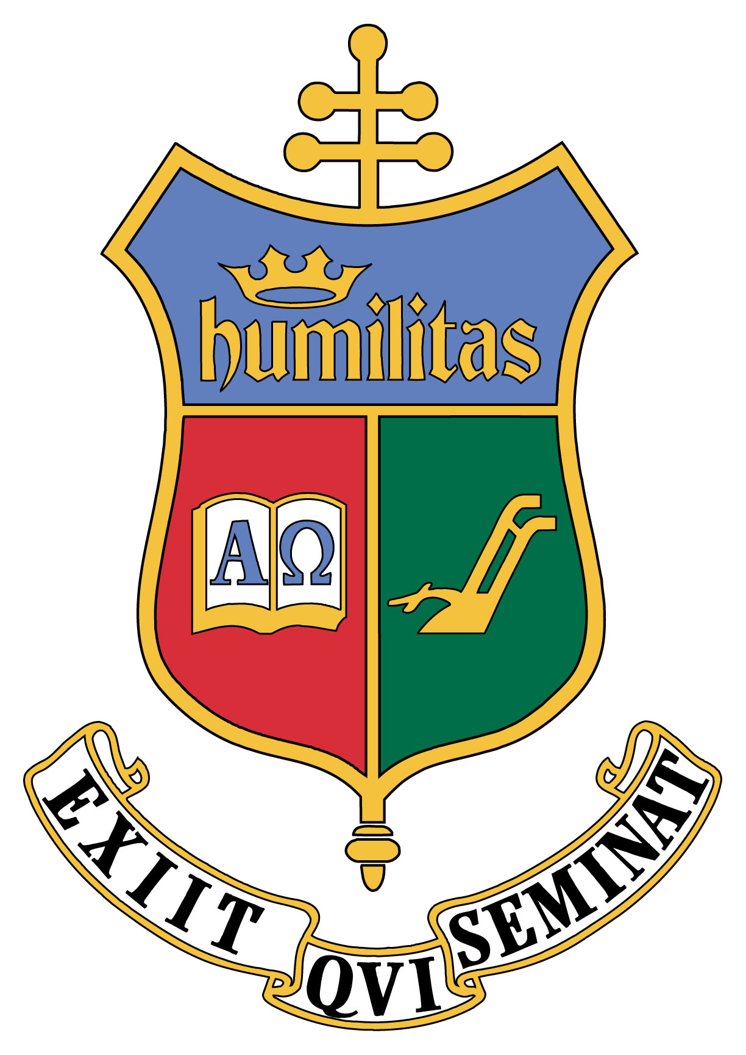
School of Diaconal Formation

Saint Charles Borromeo Seminary
100 East Wynnewood Road | Wynnewood, PA 19096
610-785-6244 | diaconate@scs.edu

Pastor’s Annual Evaluation

If more space is needed, please use the reverse side. Thank you.

Name of Candidate:

Parish:

I. Please list the areas of ministry in which your candidate has been involved during his formation.

II. How has he performed in these areas? (This includes but is not limited to: fidelity to tasks assigned; competency; how he works with authority and with others)

III. Since your candidate’s last review, comment specifically on his knowledge of the “things of the altar”, altar presence; ability to serve/assist during liturgy and devotions; any other aspects related to this area of ministry.

IV. Do you perceive any particular ministerial competency or gifts which mark this candidate’s pastoral activity? Please describe.

V. Do you perceive any significant formation deficiency which needs to be addressed during the rest of this candidate’s formation? Please describe.

VI. Overall Evaluation

1. How would you assess his overall strengths and areas of need for growth?

Strengths:

a.

b.

c.

Areas of need for growth:

a.

b.

c.

VII. Recommendation for continuing in diaconal formation

Do you recommend that he continue?

Yes _______

I do not recommend at this time because

Signature:

Date:

SEAL (not necessary if completing form electronically)

